# Original image

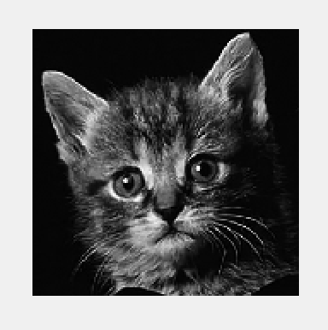

# Guided filtered images

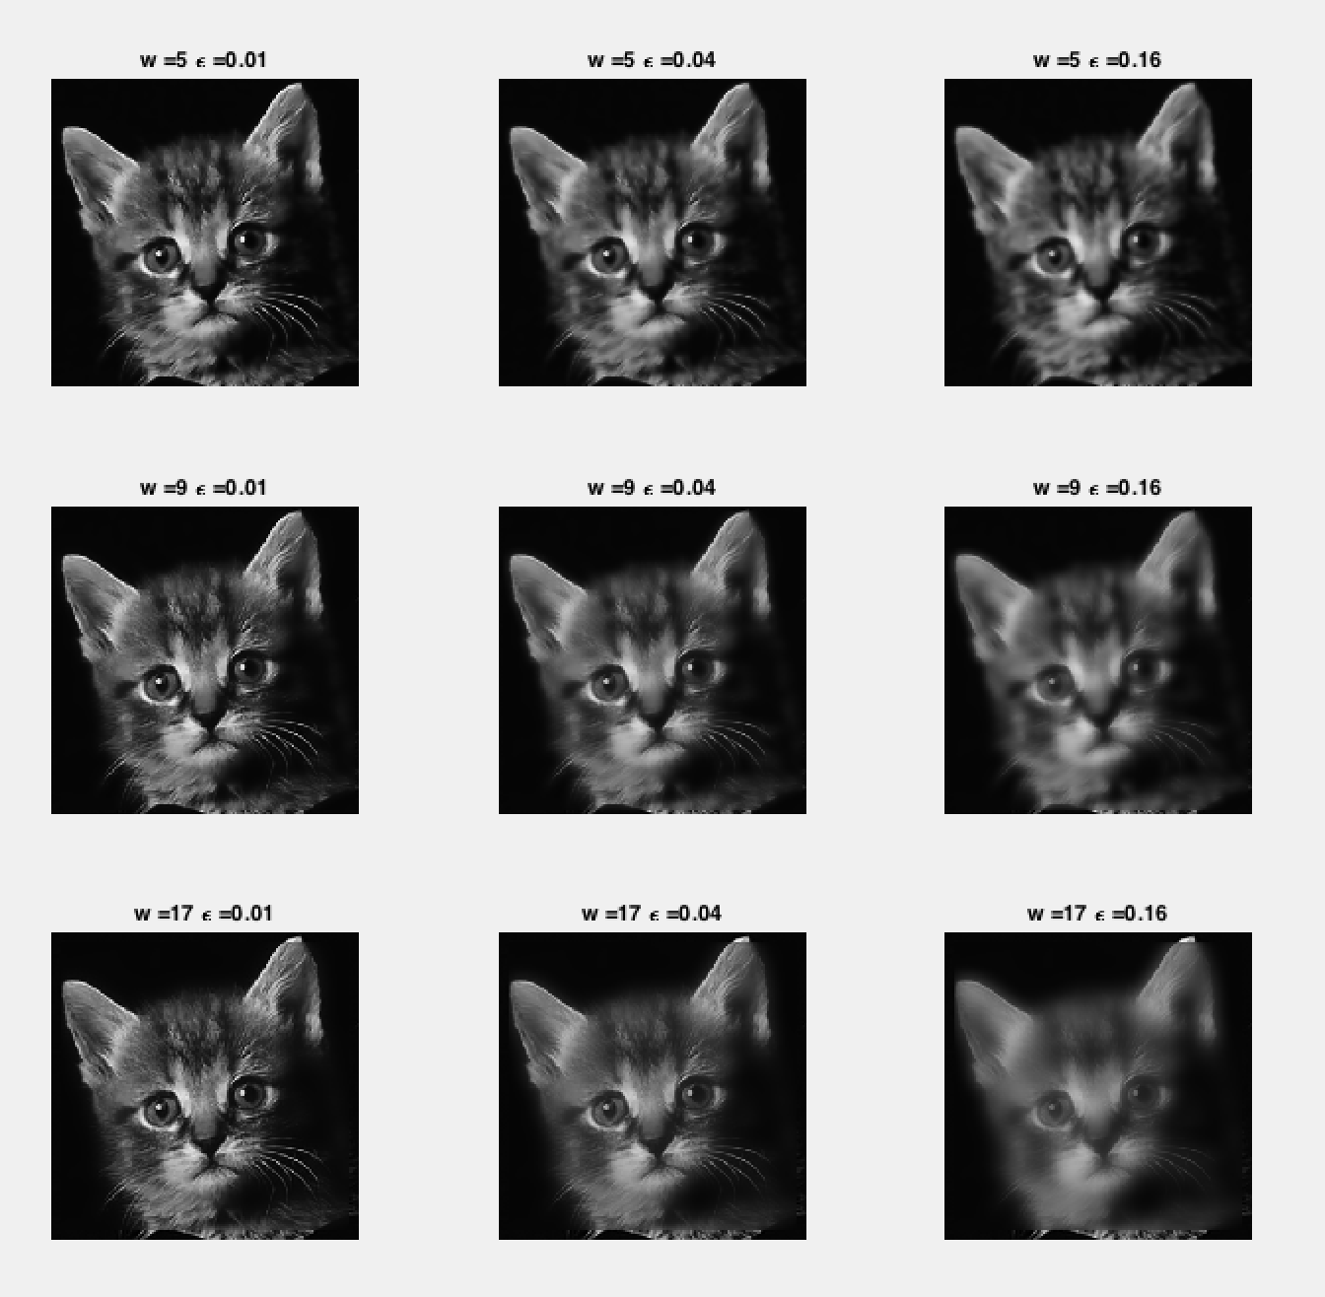

# Observations

Guided filter acts as an edge preserving filter when the guidance image and input image are same. It preserves strong edges in the filtered image and smoothens the areas where there are no strong edges.

The primary assumption of the guided filter is that the output image is a linear transform of guidance image $I$. The transform coefficients vary for a window size of $w_{k}$.

The coefficients are calculated as

$a_{k}= \frac{σ_{k}^{2}}{σ_{k}^{2}+ϵ}$ and $b_{k}=\left(1-a_{k}\right)μ_{k}$

where $a_{k}, b_{k}$ are the coefficients of linear transform of $I$ over the window $w_{k}$, and $μ_{k}, σ_{k}^{2}$ are the mean, variance of the $I$ over $w_{k}$. $ϵ$ is a regularization parameter for $a_{k}$, it affects the degree of smoothness.

If $w_{k}$ contains an edge, $σ_{k}^{2}$ would be very large than $ϵ$, which results in a value of $a_{k}$ close to 1, value of $b_{k}$ close to 0. If $w_{k}$ does not contain an edge, $σ_{k}^{2}$ would be smaller than $ϵ$, that makes the value of $a_{k}$ close to 0, value of $b_{k}$ close to $μ_{k}$. Hence the edges are copied as is to the output image from $I$, but the areas which does not contain any edges are replaced with the mean of $I$ over the window $w_{k}.$

As we increase the value of $ϵ$,we will have $a_{k}≪1, b_{k}≈μ_{k}$, hence the output image contains smoothened values. If we increase the value of $w,$ we will have $σ_{k}^{2}≪ϵ$ which again results in $a_{k}≪1, b_{k}≈μ_{k}$.